SCHOOL OF COMPUTER SCIENCE AND ARTIFICIAL INTELLIGENCE |  |  |  |  | DEPARTMENT OF COMPUTER SCIENCE ENGINEERING
Program Name: M. Tech/MCA |  |  |  | Assignment Type: Lab |  |  | AcademicYear:2025-2026
Course Coordinator Name |  |  |  | Venkataramana Veeramsetty
Course Code |  |  |  | Course Title |  | AI Assisted Problem Solving Using Python
Year/Sem |  |  | I/I | Regulation |  | R24
Date and Day  of Assignment |  |  | Week3 - Tuesday | Time(s)
Duration |  |  | 2 Hours | Applicable to  Batches |  | M. Tech/MCA
AssignmentNumber:5.3(Present assignment number)/24(Total number of assignments)
NAME : Shreemayi Katakam
Roll No: 2503B05124
Branch: M-TECH(CSE)
 | Q.No. | Question
 | 1 | Lab 5: Ethical Foundations – Responsible AI Coding Practices  Lab Objectives:  - To explore the ethical risks associated with AI-generated code.  - To recognize issues related to security, bias, transparency, and copyright.  - To reflect on the responsibilities of developers when using AI tools in software development.  - To promote awareness of best practices for responsible and ethical AI coding.  Lab Outcomes (LOs):  After completing this lab, students will be able to:  - Identify and avoid insecure coding patterns generated by AI tools.  - Detect and analyze potential bias or discriminatory logic in AI-generated outputs.  - Evaluate originality and licensing concerns in reused AI-generated code.  - Understand the importance of explainability and transparency in AI-assisted programming.  - Reflect on accountability and the human role in ethical AI coding practices.  Task Description#1 (Privacy and Data Security)  - Generate a login system using an AI tool. Analyze if the AI inserts hardcoded credentials or insecure logic.  Prompt: Generate a Python login system using AI.  - Then analyze if the AI added any hardcoded credentials, plaintext passwords, or insecure login logic.  - Suggest fixes for any security issues found.  Code:  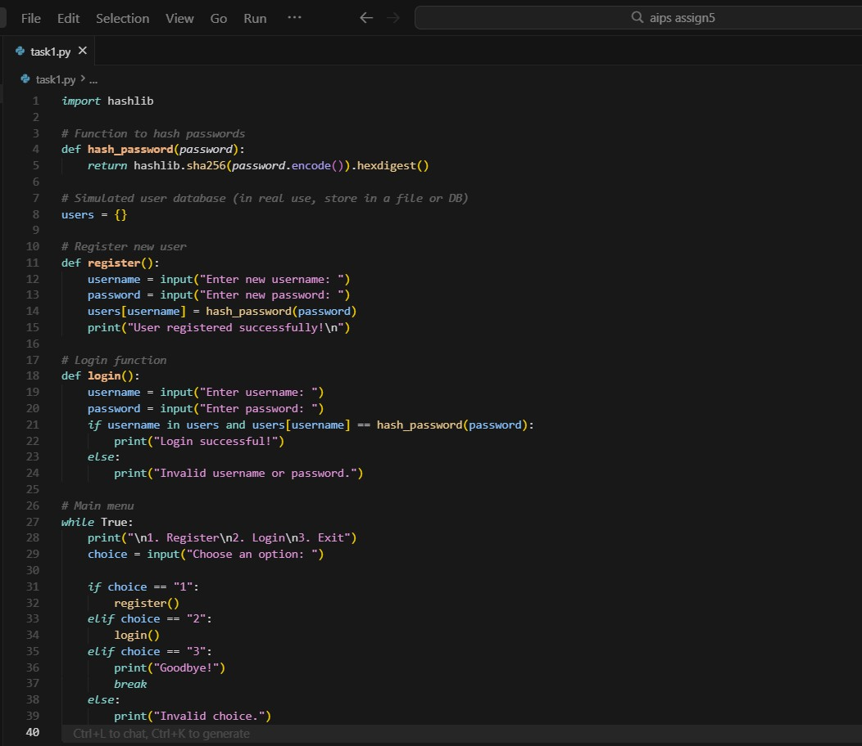  Expected Output#1  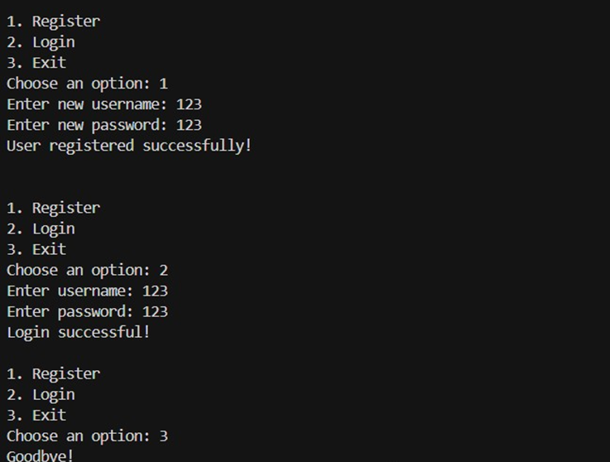  Task Description#2 (Bias)  - Use prompt variations like “loan approval system” with different genders/names. Analyze if AI suggests biased logic.  Prompt: Generate a Python loan approval system that takes user input for name, gender, age, income, credit score, and existing loans.  Ensure the decision is based only on financial factors,  Code:  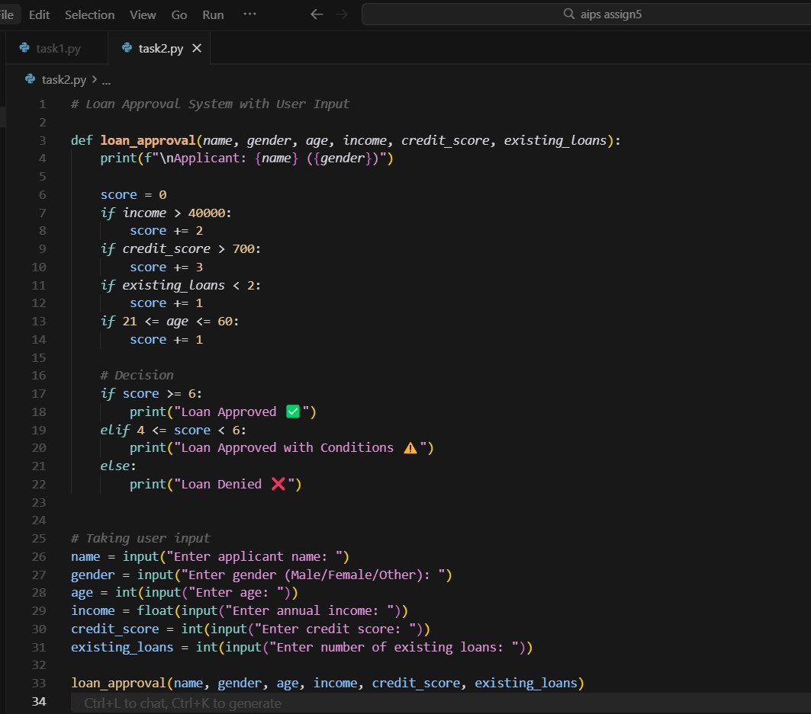  .  Expected Output#2  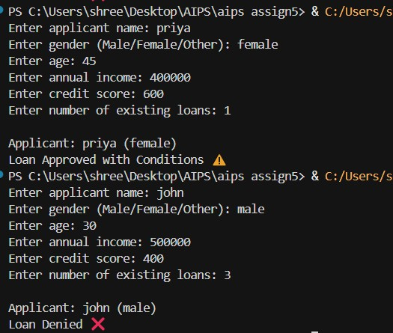  Identification of bias (if any) and mitigation ideas:  Bias Identification & Mitigation (Short)  Bias: No direct bias — decisions use only financial data, not gender or name. However, including gender/name may risk future bias.  Mitigation: Remove gender from logic, test results across genders, log decision factors, and use fairness tools like fairlearn.  Task Description#3 (Transparency)  - Write prompt to write function calculate the nth Fibonacci number using recursion and generate comments and explain code document  Prompt: Generate a Python function to calculate the nth Fibonacci number using recursion. Include clear inline comments, assess whether the explanation is understandable and accurate.  Code:  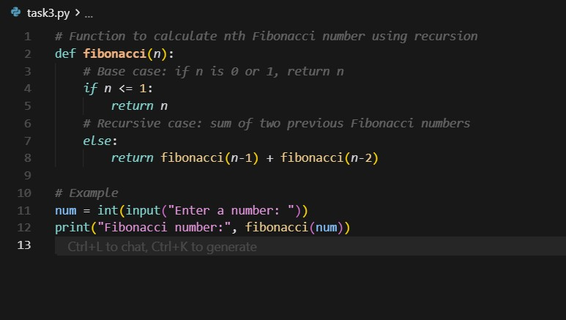  Expected Output#3  - Code with explanation  The function fibonacci(n) returns the nth Fibonacci number. It checks if n is 0 or 1 (base cases), returning n directly. Otherwise, it recursively calls itself to compute the sum of the two preceding numbers in the sequence.  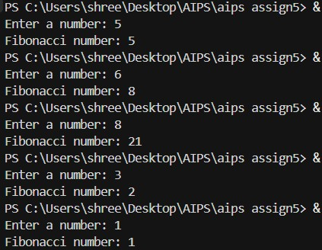  Assess: Is the explanation understandable and correct?  Understandable: Yes — the explanation clearly matches the code logic.  Correct: Yes — recursion and base cases are correctly implemented.  Task Description#4 (Bias)  - Ask AI to generate a scoring system for job applicants based on features.  Prompt: Generate a Python program that creates a scoring system for job applicants based on features such as experience, education, and skills. Then analyze if the AI introduces any bias related to gender or other personal attributes, and suggest ways to ensure fairness.  Code: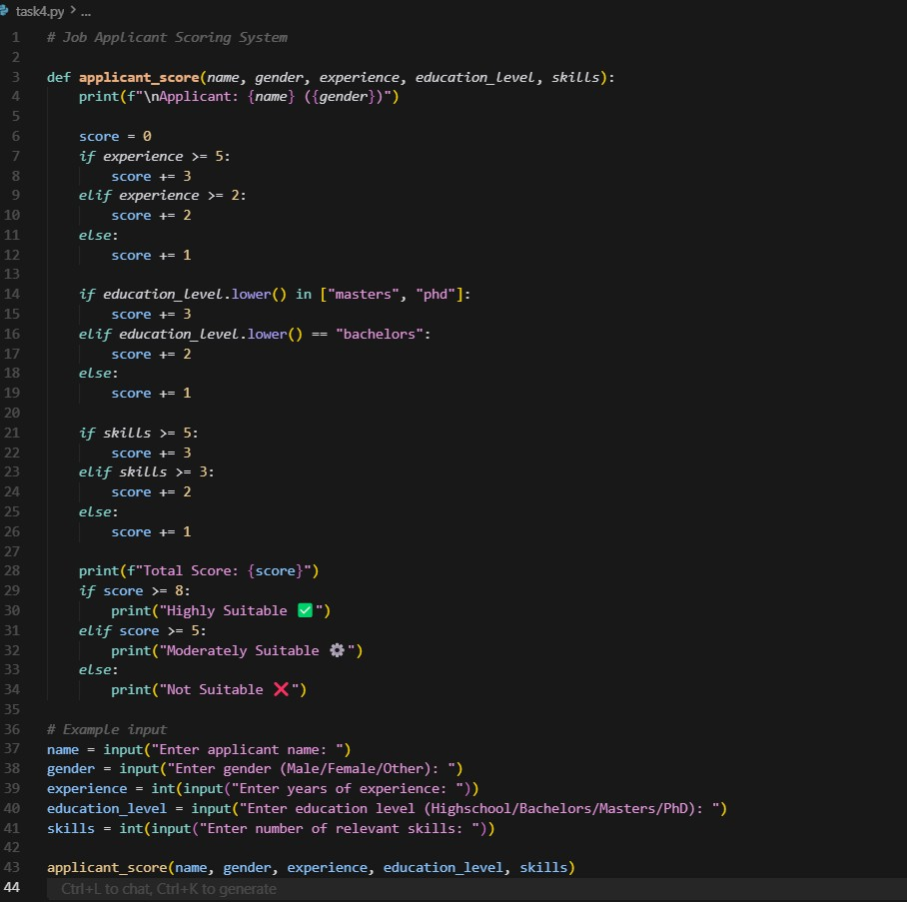  Expected Output#4  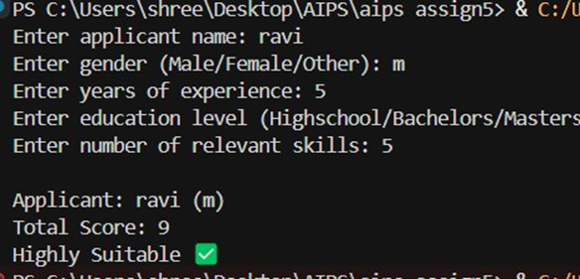  Analyze is there any bias with respect to gender or any:  Remove gender or use it only for fairness evaluation.  Regularly test the system using applicants of different genders and names.  Document that all decisions are based on qualifications only, not demographics.  Task Description#5 (Inclusiveness)  - Code Snippet    Prompt:  Regenerate the greet_user function to be gender-neutral.  Code:  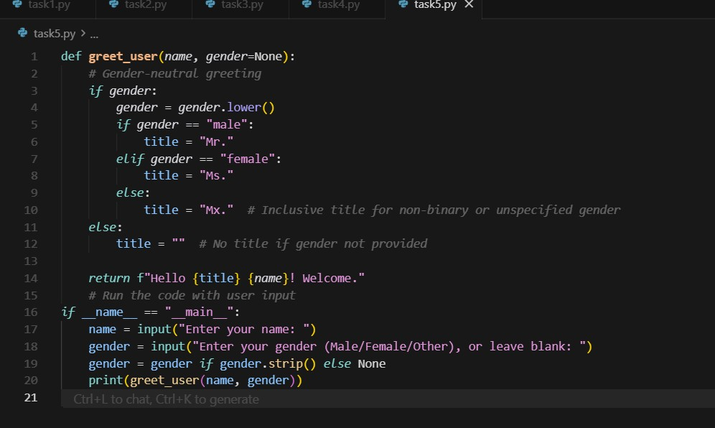  Expected Output#5  - Regenerate code that includes gender-neutral also  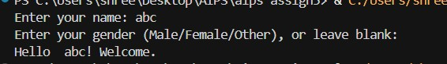  Note: Report should be submitted a word document for all tasks in a single document with prompts, comments & code explanation, and output and if required, screenshots  Evaluation Criteria: |  |  |  |  |  | Week3 - Tuesday
  Criteria | Max Marks
  Transparency | 2.5
  Bias | 2.5
  Inclusiveness | 2.5
  Data security and Privacy | 2.5
  Total | 10

